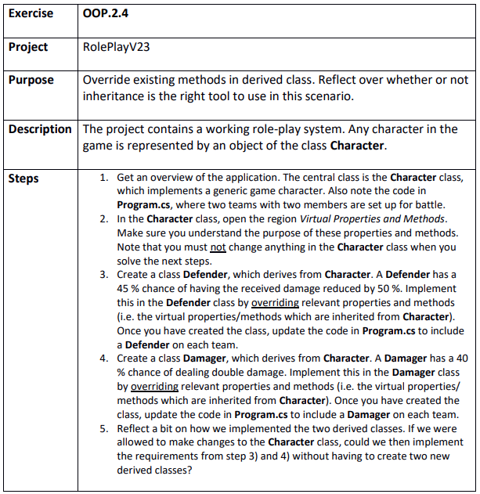

Step 1 & 2
RolePlayV23.sln

Step 3
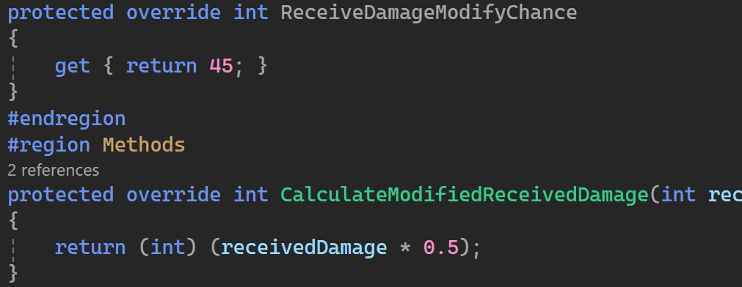

Step 4
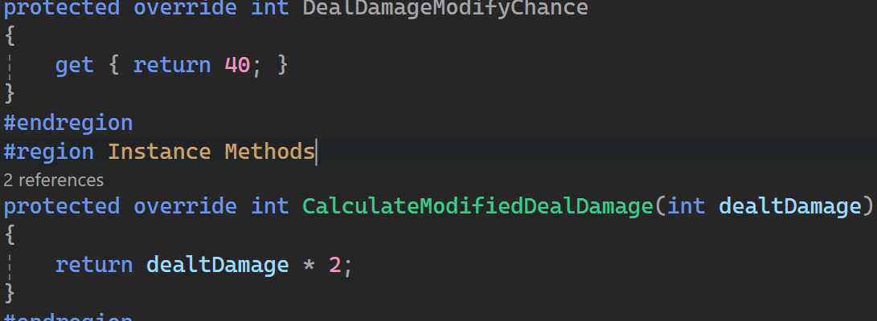

Step 5
We could just have a enum with the type of the character and then switch based on the type to make DealDamage unique

